

American International University-Bangladesh (AIUB)  
**Department of Computer Science  
Faculty of Science &Technology (FST)  
Fall 21_22**

**Section: H  
Group No: 8**

Bus Card App

A software Engineering project submitted

By

|  |  |  |  |
| --- | --- | --- | --- |
| S/N | Student Name | Student ID | Contribution (%) |
| 28 | Afrida Mahrin Chowdhury | 20-42729-1 | 30 |
| 03 | Tanvir Chowdhury | 20-42699-1 | 30 |
| 01 | Sunjida Esha | 20-42705-1 | 25 |
| 25 | SM Asif Rahman | 18-37673-1 | 15 |
|  |  |  |  |

The project will be Evaluated for the following Course Outcomes

|  |  |
| --- | --- |
| Your Project will be Evaluated based on the following marking criteria | Total Marks |
|  |
| Requirements Analysis (functional, quality, and project requirements) [5Marks] |  |
| System Design (UI/UX design) [5Marks] |  |
| Test and Project Management Planning [5Marks] |  |
| Submission, Completeness, Spelling, Grammar and Organization [5Marks] |  |

Submission Date: 10/12/21

Description of Student’s Contribution in the Project work

|  |
| --- |
| Student Name: Afrida Mahrin Chowdhury  Student ID: 20-42729-1  Contribution in Percentage (%): 30  Contribution in the Project:   * Contribution Description :1.1,1.2 ,1.3 * Contribution Description :3   _Afrida Mahrin Chowdhury _________________  Signature of the Student |
| Student Name: Tanvir Chowdhury  Student ID: 20-42699-1  Contribution in Percentage (%): 30%  Contribution in the Project:   * Contribution Description 1: 2 * Contribution Description 2: 4.1,4.2   __ Tanvir Chowdhury _________________  Signature of the Student |
| Student Name: Sunjida Esha  Student ID: 20-42705-1  Contribution in Percentage (%): 25  Contribution in the Project:   * Contribution Description 1: 4   __ Sunjida Esha _________________  Signature of the Student |
| Student Name: SM Asif Rahman  Student ID: 18-37673-1  Contribution in Percentage (%):15  Contribution in the Project:   * Contribution Description 1: 1.1   _ SM Asif Rahman __________________  Signature of the Student |
| Signature of the Student |

# PRODUCT AND PROJECT DESCRIPTION

## System Features

1. **Payment method**

**Functional Requirements**

* 1. The app will allow user to select one payment method from Bkash, Nogod, online credit or debit card and set it as default.
  2. The default payment method can be changed any time.
  3. Every single payment method a user adds will be verified.
  4. If all the information is correct, the account will be approved and user can use the app freely.

Priority Level: High  
Precondition: User must upload required documents and identification

Cross-reference: N/A

1. **Scanning/Generating QR Code**

**Functional Requirements**

* 1. The app will generate a unique QR code for every user. Scanner on the bus will read the QR code.
  2. If QR coder scanner of a certain bus if broken, the user can also scan the QR code provided by the bus itself.

Priority Level: High

Precondition: User must have a smartphone with a working camera

1. **Searching bus route**

**Functional Requirements**

* 1. User can add destination and look for all available bus routes
  2. User will be able suggested the easiest, fastest, and cheapest route through Google Map’s API.

Priority Level: Medium  
Precondition: User must be connected to the internet

1. **Bus’s live location**

**Functional Requirements**

* 1. Every bus registered with the app will have a unique number associated with it.
  2. The app will show the current location of every single bus on the user specified route.
  3. User can click on any bus shown on the route and see how fast or slow its moving.

Priority Level: Medium

Precondition: User must be connected to the internet

1. **Automatic Payment**

**Functional Requirements**

* 1. The app will charge the user according to how many bus stops the user has crossed.
  2. QR code reader on the bus’s front and exit gate will scan user’s QR code every time he gets on and off the bus. This will allow the system to charge fare accordingly.
  3. If a user tries to commit fraud by getting off a bus without scanning during exit, their account will be automatically charged for 7 stops and will be locked.

Priority Level: High

Precondition: User must have a valid payment method

1. **Membership**

**Functional Requirements**

* 1. A user can check their travel history of past 365 days.
  2. If a user follows the same route and rides the same bus company for a month, they will be offered a membership discount through the app.

Priority Level: Low

Precondition: User must use the app for at least a month

## System Quality Attributes

* List of system quality attributes: Performance, Efficiency, Integrity, Interoperability, Flexibility, Reliability, Robustness & Usability.
* **Performance:** Every page will download in 6 seconds or less if the internet speed is 1 mbps.
* **Efficiency:** This app will use at least 10 percent of the processor capacity and RAM available to the application shall be unused at the planned peak load conditions.
* **Integrity:** Only users with verified NID/Passport and verified payment method will be allowed to register for the app.
* **Interoperability:** The search system will be able to show routes, traffic, bus’s live location through Google Map’s API.
* **Flexibility:** A maintenance programmer with 1 year experience will be able to run tests and make modifications in no more than 1 hour.
* **Reliability:** 2 or less experimental runs out of 100 may be lost because of software failures.
* **Robustness:** If the app crashes while searching for routes or looking at a bus’s location, the app will take the user right back at the same page if reopened within 10 minutes.
* **Usability:** An experienced user will be search, select and see bus’s movement in an average of 1 minute.

## Project Requirements

* **Phases** : Initial Phase

**Environment**: This is a mobile app for people who use public transportation daily or occasionally.

**Resources**: There are no applications available as such in Bangladesh currently.

**Duration**: 1 week.

**Cost**: 100000.

* **Phases:** Planning phase

**Environment:** This application can be used on any mobile device. Its database will be built with.NET Core, C#, and MySQL.

**Resources:** .NET Core, C# and MySQL will be used to develop this app.

**Duration:** 1 week.

**Cost:** 15,000.

* **Phases:** Development phase

**Environment:** A development team of 10 programmers will be divided into groups of 2 or 3, each of which will work at a single workstation.

**Resources:** The development teams will be provided all the documents required.

**Duration:** 6 weeks.

**Cost:** 200000.

* **Phases:** Testing Phase

**Environment:** The initiative has a good probability of success.

**Resources:** The Project Manager will appoint a Software Testing Team to execute the project's test cases.

**Duration:** 2 weeks.

**Cost:** 50000.

# SYSTEM DESIGN SPECIFICATION

## UI/UX Design

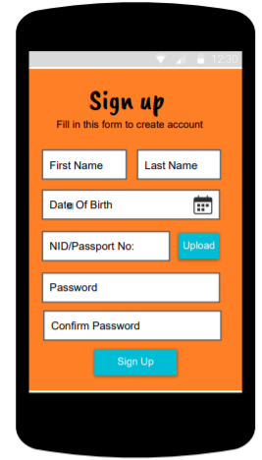

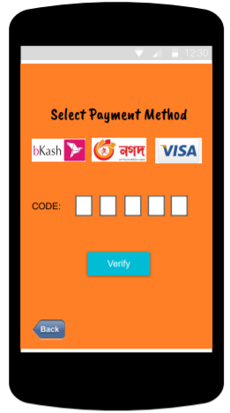

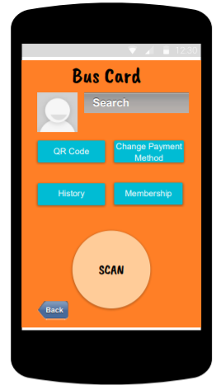

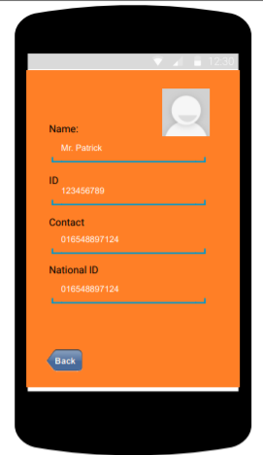

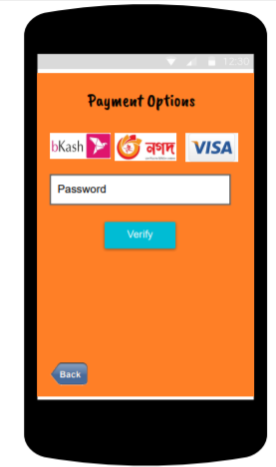

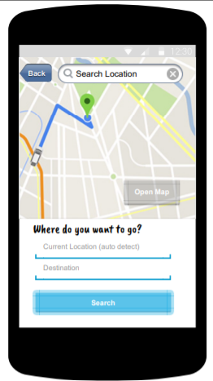

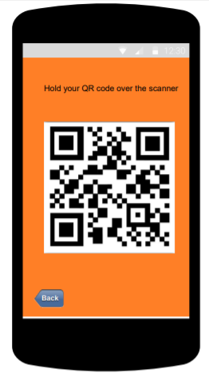

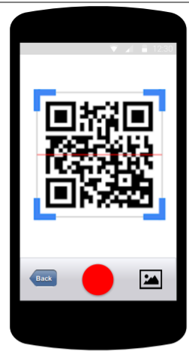

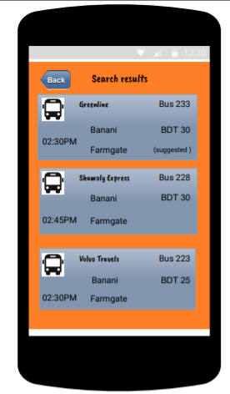

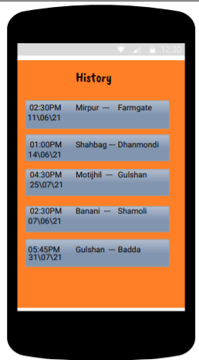

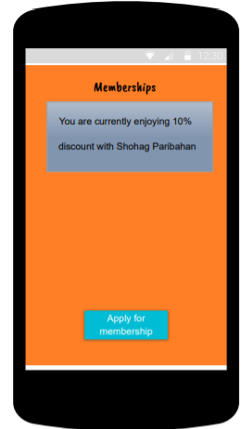

# SYSTEM TEST PLAN

* Bus card application is a mobile exclusive app.

|  |  |  |  |  |  |
| --- | --- | --- | --- | --- | --- |
| Project Name: Bus Card App | | | Test Designed by: Afrida Mahrin | | |
| Test Case ID: FR_1 | | | Test Designed date:10.03.21 | | |
| Test Priority (Low, Medium, High): High | | | Test Executed by: | | |
| Module Name: Search option | | | Test Execution date: | | |
| Test Title: Bus route search | | | | | |
| Description: Search and show all the available bus routes from one location to another and suggest the easiest route | | | | | |
| Precondition (If any): User must have internet connection | | | | | |
| Test Steps | Test Data | Expected Results | | Actual Results | Status (Pass/Fail) |
| 1. Go to the app 2. Press search 3. Enter current location 4. Enter destination 5. Click search | Current location: Shemoli  Destination: Mohakhali | Users will see all the busses available on that route | |  |  |
| Post Condition: User is shown the bus routes and suggested the fasted bus. | | | | | |

**Test case 1:**

**Test case 2:**

|  |  |  |  |  |  |
| --- | --- | --- | --- | --- | --- |
| Project Name: Bus Card App | | | Test Designed by: Afrida Mahrin | | |
| Test Case ID: FR_2 | | | Test Designed date:19.03.21 | | |
| Test Priority (Low, Medium, High): Medium | | | Test Executed by: | | |
| Module Name: Location ping | | | Test Execution date: | | |
| Test Title: Bus live location | | | | | |
| Description: Click on a certain bus generated from search and see its live location | | | | | |
| Precondition (If any): User must have internet connection | | | | | |
| Test Steps | Test Data | Expected Results | | Actual Results | Status (Pass/Fail) |
| 1. Search for route or a certain bus number 2. Click on the bus | Search: Bus #22 | Users will see bus #22’s current location | |  |  |
| Post Condition: User is shown bus’s live ping and shown how fast it will arrive | | | | | |

**Test case 3:**

|  |  |  |  |  |  |
| --- | --- | --- | --- | --- | --- |
| Project Name: Bus Card App | | | Test Designed by: Afrida Mahrin | | |
| Test Case ID: FR_3 | | | Test Designed date:29.03.21 | | |
| Test Priority (Low, Medium, High): High | | | Test Executed by: | | |
| Module Name: QR code | | | Test Execution date: | | |
| Test Title: Scan QR code | | | | | |
| Description: Scan QR code on bus to validate payment | | | | | |
| Precondition (If any): User must have internet connection | | | | | |
| Test Steps | Test Data | Expected Results | | Actual Results | Status (Pass/Fail) |
| 1. Go to homepage 2. Click on “Scan QR code” 3. Hold phone’s camera in front of the QR code | N/A | QR code is scanned | |  |  |
| Post Condition: User payment is validated | | | | | |

**Test case 4:**

|  |  |  |  |  |  |
| --- | --- | --- | --- | --- | --- |
| Project Name: Bus Card App | | | Test Designed by: Afrida Mahrin | | |
| Test Case ID: FR_4 | | | Test Designed date:29.03.21 | | |
| Test Priority (Low, Medium, High): High | | | Test Executed by: | | |
| Module Name: Efficiency | | | Test Execution date: | | |
| Test Title: Verify how much unused space remains | | | | | |
| Description: Test how much resource the app consumes | | | | | |
| Precondition (If any): N/A | | | | | |
| Test Steps | Test Data | Expected Results | | Actual Results | Status (Pass/Fail) |
| 1. Go to app 2. Use any function | N/A | There should be at least 85% space free in ram and processor. | |  |  |
| Post Condition: N/A | | | | | |

**Test case 5:**

|  |  |  |  |  |  |
| --- | --- | --- | --- | --- | --- |
| Project Name: Bus Card App | | | Test Designed by: Afrida Mahrin | | |
| Test Case ID: FR_5 | | | Test Designed date:30.03.21 | | |
| Test Priority (Low, Medium, High): High | | | Test Executed by: | | |
| Module Name: Reliability | | | Test Execution date: | | |
| Test Title: Verify Reliability of the software | | | | | |
| Description: Test how many times the software fails | | | | | |
| Precondition (If any): N/A | | | | | |
| Test Steps | Test Data | Expected Results | | Actual Results | Status (Pass/Fail) |
| 1. Go to app 2. Run the app 100 times | N/A | The system should not fail more than 2 times | |  |  |
| Post Condition: N/A | | | | | |

**Test case 6:**

|  |  |  |  |  |  |
| --- | --- | --- | --- | --- | --- |
| Project Name: Bus Card App | | | Test Designed by: Afrida Mahrin | | |
| Test Case ID: FR_6 | | | Test Designed date:31.03.21 | | |
| Test Priority (Low, Medium, High): High | | | Test Executed by: | | |
| Module Name: Usability | | | Test Execution date: | | |
| Test Title: Verify Interface | | | | | |
| Description: Test how friendly interface is | | | | | |
| Precondition (If any): N/A | | | | | |
| Test Steps | Test Data | Expected Results | | Actual Results | Status (Pass/Fail) |
| 1. Go to app 2. Click on search, click on bus | From: Mirpur  To: Banani | The interfaces should not take more than 2 second to change to another. | |  |  |
| Post Condition: N/A | | | | | |

# PROJECT MANAGEMENT PLAN

## Project Scheduling

* Project Management and Categorize:

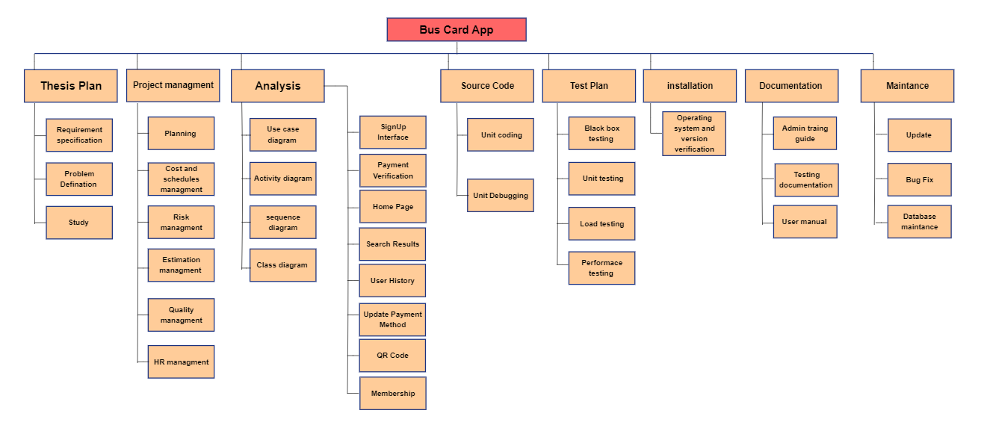

* Effort estimation and schedule:

Effort = PM = Coefficient<Effort Factor> * (SLOC/1000)^p

= 2.4 * (6000/1000)^1.05

= 15.75

Development Time = DM

= 2.50*(PM)^T

= 2.50* (15.75)^0.38

= 7.13 months

= 28 weeks

Required number of people = ST

= (PM/DM)

= (15.75/7.13)

= 2.20

=3

* Timeline Charts:

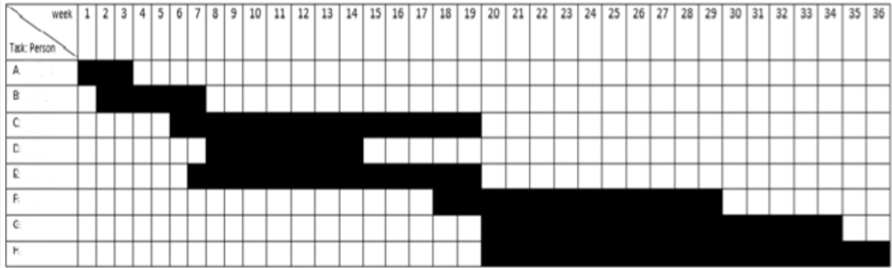

Activity key: A: Analysis B: Project Management

C: Design D: Software Build

E: Testing F: Documentation

G: Installation H: Maintenance

## Risk Analysis

|  |  |  |  |  |
| --- | --- | --- | --- | --- |
| **S/N** | **Risk Description** | **Probability** | **Impact** | **Mitigation Plan** |
| 1 | Addition of unknown features | 30% | High | Proper planning |
| 2 | Over optimistic schedule | 40% | Medium | Distribute enough time |
| 3 | New graphic system unstable | 30% | Medium | Launching app with latest graphics sub system |
| 4 | Facilities not ready in time | 40% | High | Acquiring necessary documentation ahead of time |
| 5 | Management reporting taking more time than expected | 40% | High | Keeping management on a strict schedule |
| 6 | Project approval takes longer | 50% | Medium | Setting up Meetings with higherups |